# **Meeting Availability:**

* In-person meetings: Monday to Wednesday mornings, 9:00 am to 1:00 pm
* Online meetings: After 10:00 pm every day via Discord or Facebook Messenger

# **To-Do List:**

* Work on the content for the book, starting with data research and analysis after completing the introduction.
* Conduct thorough research on patterns of migration, reasons for migrations, opportunities, and survival to combine charts.
* Work on the website that showcases the visualization, including its appearance and functionality. Add an HTML page and CSS effects for appearance, along with optional functions using JS methods and D3 for charts.

**Screenshots:** We will keep track of relevant progress during the project and provide updates on a regular basis, including screenshots as required.

Here are some examples down below.

Github: 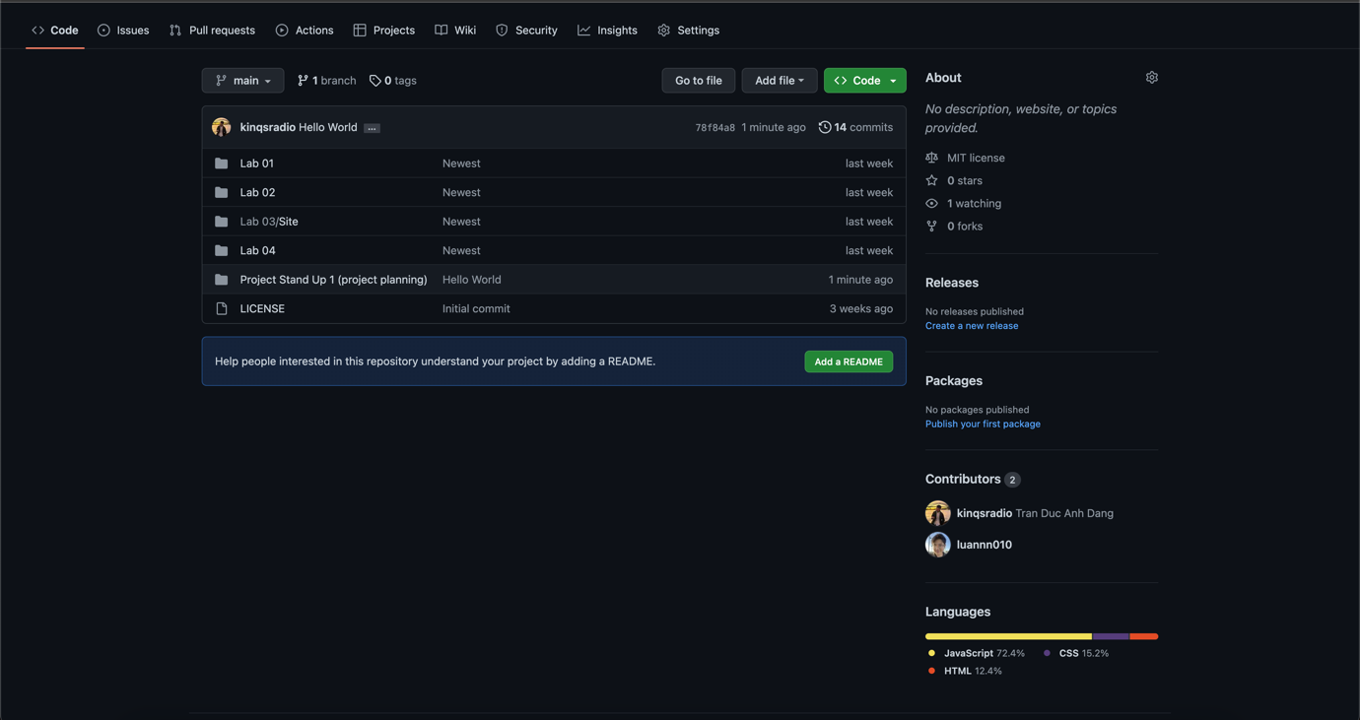

Facebook/Discord:

We have been using Facebook and Discord as well as catching up every morning to plan a head of the week. Here is one of the example that we've been working together on other courses.

Document sharing and schedule:

We meet most likely every morning and using our GitHub as file/documentation sharing as well as Airdrop function on our Mac.

# **Schedules:**

* Week 2: Start working on the project. Summarize the project objectives and create a GitHub repository for group work.
* Week 3-4: Work on the project.
  + Prepare the appearance of the project process book.
  + Add some content with a focus on motivation and background (introduction).
  + Set up the website with some function or label, focusing on using HTML.
  + Plan the type of geometric that will be added to the project for data presentation.
* Week 5-7: Focus on data research and analysis.
  + Conduct research for needed data as discussed in Week 3.
  + Process data and convert it to charts using D3 for data presentation.
  + Provide details on data cleaning and acquisition for the workbook.
* Week 8: Finish working on the website.
  + Add suitable functions to present data properly.
  + Add some CSS effects to make the website look better.
  + Add JS for converting data using D3.
  + Check with the tutor.
* Week 9: Finalize the project process book.
  + Complete the content.
  + Add references.
  + Fix any grammar and spelling mistakes.
* Week 10-12: Finalize the project.
  + Receive feedback from the tutor to fix all issues.
  + Submit the final project.